Exhibition overview
The Montclair Art Museum's Rotunda features the display of various art objects acquired from various sources. The exhibition will take a duration of three months beginning from 26th December 2017 to 26th March 2018. The Montclair Art Museum's Rotunda will be used as the designated exhibition space for the artefacts. The rotunda has four architectural alcoves where the objects will be displayed.
Preparing the Gallery Space
- Art objects to be assembled first at the Montclair Museum storage after being received from the sources prior their installation in Rotunda.
- Use the alcove dimensions to analyze and identify where best the specific objects will get installed as well as other needed equipment like lighting.
- Maintain the statue residing at the center of Rotunda as the gallery has enough space for navigation
- Cover the furniture in this space during installation of the objects and uncover post installation.
- Alcoves interior walls should be painted an off-or hang soft grey curtains to act as an ideal background to achieve visual contrast between the art object and the wall.
- Exhibition should be open a few days after objects are installed, allowing time to make sure hardware stay stable.

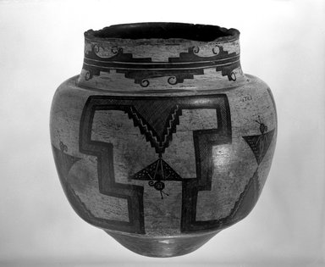
Object One: Water Jar
Object Name: Water Jar
Culture: She-we-na (Zuni Pueblo), Native American
Medium: Clay, pigment
Dates 1825-1850
Dimensions: 12 3/4 x 12 3/4 in. (31.5 x 33.5 cm) (show scale)
Collections: Arts of the Americas
Museum Location: Newark Museum
Exhibitions Accession Number: 03.325.4723

Catalogue Description:
Jar, black on white exterior. This oversize water jar has a butterfly design, a symbol often associated with water, set within a large, continuous stepped figure on the body. The neck design consists of a continuous stepped band with curled figures attached. In use it would have a piece of hide stretched and tied across the top, thus accounting for the rough edges on the jar. Red writing on base reads "03.325.4723" and "03.132," partial number is written in black on the side.
The water jar has a predominant organic shape that has been complimented by a geometric shape. With flat horizontal lines running across the jar, the artifact is stable once placed on a flat platform. This tool has over the years been used by the pueblos to carry and store water. As a fine art, the collection is modelled using clay and painted using charcoal, animal blood and minerals. This object is hence fragile and should be handled with care and great concern.
Shipping
This object is a local transit which is feasibly hand delivered from the Newark to the Montclair Art museum Rotunda facility. One of the most important factors in selecting a particular art packer or carrier is its reputation with other museums. Contact local museums for recommendations on tried and tested museum object handlers and shipping companies. After a company has been selected, discuss and confirm the following points of information about the shipment: i.e. size and weight limitations, insurance coverage, costs, payment terms, pick up point and the delivery times. Amongst the key issues that should be addressed in the process of shipping is identify the respective local store where the pottery artifact will be sourced from.
Newark Museum Pottery Storage is where the clay water jar will be sourced from. This museum has a wide collection of art pottery hence the ideal source to get one. Additionally the representatives in the museum offer advice, procedure on how to display and handle the artefact. They also recommend the best means of packaging that ensures the art object not only portable but safe from theft or damage such as cracking. It is also notable that Newark Museum offers competitive prices on hiring the pots as well as buying them with a room for negotiation and discounts making it a better deal that can cut cost but still get the quality of the artefact and the services provided
Once that is identified, it is important to notify the relevant authorities on the movement of the pottery. This incorporates the management in the store and the legal enforcement. This process will incorporate signing the respective papers that are essential for exchange. Transporting the Antique Native American Polychrome Pottery Jar will demand ultimate care to ensure that the commodity is properly and safely transported across the city to the Montclair museum.
Finally, be prepared to supervise and give specific instructions for shipping objects. If the handlers are also packing they should be supervised by the designated staff member. Once the terms are observed, the delivery and condition of the pottery will be determined and based on the terms of the contract in the cause of a risk causing damage.
It is essential and appropriate to write on the shipping box that the object in the box is delicate and should hence should be handled with care. The security of the object is paramount. The location of the exhibition must secure to ensure the object remains safe from either robbery or stealing. While shipping the water jar artefact, the wooden box should be used. However, it should leave enough space for the art object as well as approximately two inches for the cushioning material such as the Styrofoam and bubble wrap, and cavity of ethafoam wrapped in tissue paper.
Before packaging it is recommended to warp the object first with the saran wraps that are transparent and plastic in nature. Materials such as newspapers should be avoided as fibre from the paper can damage the jar making it lose its originality and value. The entire pot should be covered using three to four layers of bubble wrap with the bubbles facing towards the pot surface. This technique provides the optimal protection as the air inside the bubbles get compressed making the shipping process effective. Preferably, the shipping should be done in a double-boxed package. However, the packaging peanuts should be used only with the outer box to securely enclose the sides of the inner box containing the pottery. Using the packing peanuts inside should be avoided at all costs as the have a thin coating of oil which can drip onto the pots damaging them.

Handling, Packaging, Moving and Storing the Object
Handling of the pottery should be done in an efficient and effective manner. The pottery is a clay made material which is sensitive to damage in the case of drop. In this regard, it is essential to handle to object with two hands and wear gloves that would ensure no marks are left on the pottery. Storage must meet the necessary requirements and specifications as the standards and museum ethics demand and specify. Every item in a museum must be sensitively preserved and stored to minimize risks the damage of the artifact. In this case the Antique Native American polychrome pottery jar must be properly stored not only to minimize risks of damage but also to ensure that the object remains in excellent and suitable condition.
While packing the pottery in the relevant box, the following process should be followed strictly; Place the object in the exterior container. The container should be protected against shock that would result to damage of the container. This container should be marked with a sign indicating the existence of a delicate object in the container. Position the object inside the container. Consider the object's weight and center of gravity and imagine which part of the object will receive the least breakage if the package is dropped. The heaviest part of the object should be placed low and as near to the center of the container as possible.
Cover and wrap the object. An initial covering will be used to protect object from abrasive packing materials and to serve as a moisture buffer. Use soft, unbuffered acid-free tissue paper. As much as possible, avoid tape when covering objects because the tape can adhere to the object. Instead, tuck the tissue in on itself or into an appendage. Be careful not to exert stress on the object by wedging tissue too tightly. Insert smooth pillows of tissue between objects.
After covering the object, round off with tissue all projecting parts and handles. Soft, unbuffered acid-free tissue will be placed around the opening of the jar. The end result is a rounded-off ball of tissue. Wrap the entire jar in one sheet of tissue or air-cap to hold the padding in place. Since this layer does not come in direct contact with the object, it can be taped to hold the package together. Label this exterior wrapping with object identification. This will include the object name and catalog number.
The following process should be keenly observed in order to remove the object from the storage or store the pottery in the storage process;
- Wear gloves in order to move the object carefully avoiding careless dropping and leaving unnecessary marks on the object.
- Determine my route to avert pathway disturbances by ensuring the path is safe and completely clear.
- Note any obstacles (thresholders between galleries, steps, etc.)
- Pay attention when removing the object from the shelf to avoid accidental damage.
- It is essential to examine if the pottery has any weakness lines that would result to breakage or destruction of property.
- Avoid wearing anything that might damage the object by scratching or snagging the surface.
- Use both hands to lift the object.
- When you handle the pottery use common sense to follow the basic to prevent damage to the Pottery
- Place the Native American Pottery on the right surface and ensure it is free from damage or risk that could cause breakage.
- Cavity of ethafoam wrapped in tissue paper.
- The Pottery may be moved on a cart if necessary – leave in its crate if being moved with a cart.
- The object can be handle by a single person, possibly two if necessary.
- Move the object in its container if possible.
Display
- The cost of the display process and exhibition must be evaluated with knowing how long the exhibition will be.
- The avenue of the location of the water jar must be to the platform where people can access it and view it with no hindrance.
- The place of the display should be safe and free from any risks that may lead to pottery breakage.
- The object should be placed on a suitable base or pedestal for greater visibility.
- Unique mount that cradles and supports the bottom.
- Create a suitable platform that will allow viewers to clearly view the pottery without hindrances.
- Create a label for exhibition to place on wall between alcoves.
Implementing the table top design will support maximum product visibility which is essential to the audience. When displaying this pottery jar art, sufficient light will be better to enhance visibility of details especially because the jar contains some paintings and patterns some lighting units will be fixed in the alcove especially above and on the sides of the jar. The water jar must be displayed halfway deep into the alcove as a preventive measure to possible accidental drops. Although there will be no window enclosure, the audience will be prohibited from touching or lifting the art object touch.
Another display technique that will be implemented will be to put larger labels on the side of the alcove to minimize congestion as well as obstruction to the artwork. These labels will be written in a huge font with a brief summary about the art object. This label will make it possible for the visitors to establish with ease if that’s their art of interest and explore it further or to move to the next available art. Making this information will surely enhance the visitors’ experiences in the alcove which can make them learn and gain more from the art objects explorations.


49 Washington Street
Newark, NJ
07102-3176
http://www.newarkmuseum.org
Incoming Condition Report
Date: December 6, 2017 Reported by: Wael Dugdugi
Accession # |  | Description |  |  |  |  | Date range
03.325.4723 |  | Jar, black on white exterior and a butterfly design |  |  |  |  | 1825-1850
Collection |  | Credit line |  |  |  |  | Location
Arts of the Americas |  | Museum Expedition 1903, Museum Collection Fund |  |  |  |  | Not on view
Materials
Clay and pigment
Dimensions in inches
Height |  | Width |  |  |  | Length
12 3/4 |  | NA |  |  |  | 12 3/4
Condition (1-4, 1 being Poor and 4 being Very Good)
Overall | Soil |  | Stains |  |  | Losses |  | Fading
4 | 4 |  | 4 |  |  | 4 |  | 3
Check all that apply:
Evidence of Insect Infestation |  | Mold/ Mildew |  | Previous Repairs |  | Unstable Dyes |  | Label
 |  |  |  |  |  | X
Condition details
The jar water jar has a small hole in the base and the rim is also worn. There is also evidence of a faded black dye as there is a partial number "03.132," written on the side.
Photographs
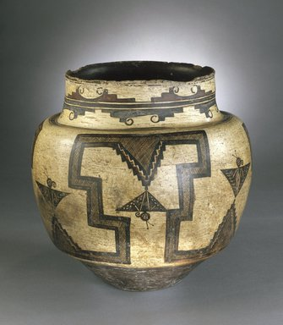 |  |  |  |  | 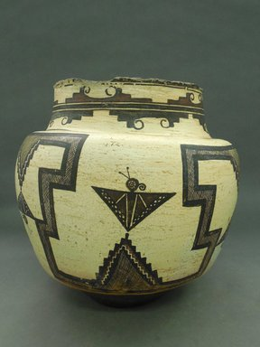
Overall recto |  |  |  |  | Overall verso

Condition Terms
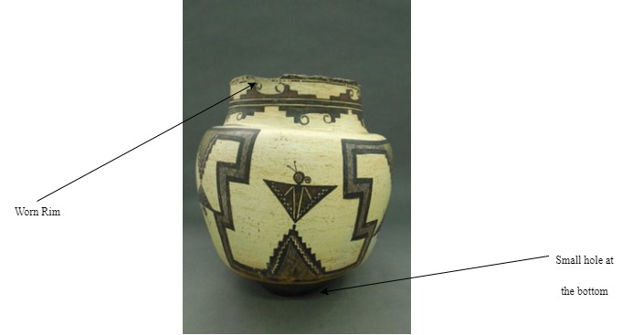


Receipt Form
Received by division of: Water Jar date: December 6, 2017

Museum representative: Osanna Urbay (Registrar) sign:

Forwarded to: Bruce Rainier (Preperator)

The objects listed are left in the temporary custody of the Montclair Art museum as a favor of the owner and on the initiative of the owner. Any opinion offered to the owner regarding the objects is for personal information and it may not be used in connection with any commercial transaction.
The museum personnel cannot make statements regarding the monetary value of an object nor are they or the museum liable for statements concerning the authenticity or identity of the object.
The museum will give the objects left in its custody the same care provided similar objects of its own, but it assumes no additional responsibilities or liabilities in regard to such objects. Insurance for objects left in custody will be carried by the owner. This receipt shall constitute a release and waiver of the Peabody museum, its employees, officers, and agents from any liability in connection with the objects while in temporary custody or in transit, except for clearly negligent conduct.
I agree to the above terms and conditions.

Signature of depositor: Date: December 6, 2017

Name of depositor: Wael Muhssen Dugdugi. Address: 25 manor drive, Newark, NJ 07106

Telephone: 001 352 278 1785

Owner/agent: Newark Museum

Address: 49 Washington Street, Newark, New Jersey Telephone: 07102-3176

Scheduled date of removal of object is: March 26, 2017
Objects have been deposited for the following purpose:

Identification: ………NA……. Examination for……NA……………….

Other: Exhibition purposes.

Description of objects deposited:

Does the owner have any objection to objects being altered for investigation?
- Yes √

- No

Please describe locality and conditions
- If found, please give exact location including city and street.
- If dug up, please describe color, texture and others and where they were found.
- If otherwise acquired, please give details. √
The water jar was hired and acquired from the Arts of the Americas collection in Newark Museum following the appropriate procedure for the item acquisition.

Objects ready for pick-up, owner notified (date): December 20, 2017

It is hereby acknowledged that the objects listed above have been returned to the owner

Received by: …………………………………... Date: …………………...

Signature: ……………………………………...

INCOMING LOAN CONTRACT
AGREEMENT
The undersigned (“Lender”) hereby places the object(s) described herein in custody of the Montclair Art Museum for the purposes, and subject to the terms and conditions, set forth.

LENDER INFORMATION:
Name: Newark Museum
Address: 49 Washington Street, Newark, NJ

Telephone: 07102-3176
Email: information@newarkmuseum.org

OBJECT(S) DESCRIPTION(S):
Object Name: Water Jar
Medium: Clay, pigment
Dates 1825-1850
Dimensions: 12 3/4 x 12 3/4 in. (31.5 x 33.5 cm) (show scale)
PURPOSES/PERMISSIONS (check all that apply):
The Museum has the Lender’s permission to use the object(s) for:
- Exhibition √  Copying/Reproduction (commercial)
- Copying/Reproduction (non-commercial)
- Research

DESCRIPTION OF LOAN:
Dates: December 26, 2017 to March 26, 2018
Responsible for transportation: Lender Museum Shipping company√

CREDIT LINE:
Unless otherwise noted, the object(s) listed above will be credited in exhibition and publication with
the statement “Courtesy of Museum Expedition 1903, Museum Collection Fund”

SIGNATURE:
The Lender acknowledges that he/she has full authority and power to enter into this agreement, that he/she has read the conditions above and on the back of
this form and that he/she agrees to be bound by them.
DATE
MUSEUM REPRESENTATIVE
Sign and date for return receipt:

LENDER DATE

LENDER Newark Museum DATE: 03/12/2017

MUSEUM REPRESENTATIVE DATE: 03/12/2017
Osanna Urbay (Registrar)


9738 Central Ave
Montclair, CA 91763
909-624-0033

Fax: 909-624-3708

CERTIFICATE OF INSURANCE
This memorandum is for information only: it is not a contract of insurance but attests that a policy as numbered herein, and as it stands at the date of this certificate, has been issued by the Company. Said policy is subject to change by endorsement and to assignment and cancellation in accordance with its terms. The following is information from tire policy.
Policy Type | Museum Collection and Temporary Loans
Named Insured | Montclair Art Museum
Address | Montclair Art Museum,  3 South Montclair Ave.  Montclair, NJ 07042
Dates | December 26, 2017 to March 26, 2018.  12:06 AM Standard time at the place of issuance.
Limits of Liability | Object value
On the following Works of Art. | Object Name: Water Jar  Artist: Unknown  Dates: 1825-1850
Company and Policy numbers. | ESI Insurance Agency Policy Number # 6709
Certificate Issued to | Lender: Newark Museum,  Address: 49 Washington Street  Newark, NJ 07102-3176

Authorized Representative: Date: December 4, 2017
Object Two: Ware Pottery
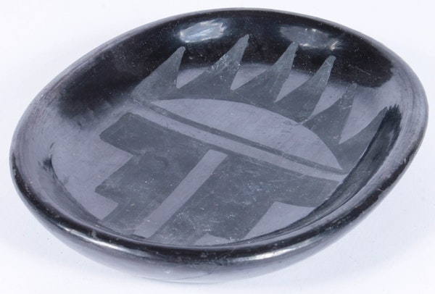
Object Name: Native American Rose Gonzales Signed Black Ware Pottery.
Artist: Rose Cata Gonzales (1900 – 1989)
Dimensions: 5.75" W x 1.0" H x 4.5" D
Condition: Good, Some light surface marks, scratches.

Catalogue Description
This round pottery dish was done by Rose Potter Rose Cata Gonzales (1900 – 1989). She is a Native American who incised black on ceramic dish. She was credited as an innovator of the deeply carved pottery technique which was greatly used by San Ildefonso potters around 1930s. The dish is almost metallic sheen and is decorated with a matte black geometric design of six triangles on an arch, with step patterns below. The underside is signed “Rose”. Rose is believed to have learned pottery making from her mother-in-law, Ramona Sanchez Gonzales.
Shipping
This will be a private object that will be sourced from Marilyn Stephen Greene’s collection. The object will be earmarked for acquisition. Hence, it will stay longer in the museum. To begin with, the object will be shipped by the Montclair museum representative will go to Marilyn Stephen Greene’s home in Newark and transport the object to MAM. Therefore, that it can be delivered in time prior to installation. The MAM representative will receive a set of instructions from the owner guiding on how to ship the delicate object to prevent damage and theft at all costs. As such, the representative will be fully responsible for the safe delivery of the object to the required destination.
Packaging the Object
During this process, observe the following protocols;
- Determine whether our hands are properly protected. Are they clean? Should we be wearing gloves?
- Examine the object carefully and learn its strengths and weaknesses. Be wary - there may be internal weakness or old (and weak) repairs that are not obvious to the naked eye.
- Keep in mind, cotton gloves should not be worn while handling glass and glazed ceramics. To prevent slippage, hands should be clean and dry or latex/vinyl gloves should be worn.
- Avoid wearing anything that might damage the object by scratching or snagging the surface.
- Check the object’s fragility and for this case it is ceramic which should be handled with care.

The packaging of the object should be determined. The box or the container to be used should be in a way that it is fit to house the object. The box should be fitted with the correct measures to allow it to make sure that there is the ability to protect the object from any scratches or even breaking because it is sensitive. The box should be fitted with foam and tissue material in all the spaces and allow for the protection in cases where the object can be shake or any other condition. The object should be handled with care. When handling the object caution should be highly observed. This is due to the ceramic material which is very fragile and easily breaks when dropped or knocked against a hard surface.
During movement of the object from one point to the other, both hands should be used to ensure its safety. When packing it, first get a box or container that is strong enough and can hold the mass of the item. Wrap the item in one layer of paper to avoid scratches, then place layers of bubble wrap and secure it with tape. In the box place some sponge on the bottom. Set the wrapped piece in the box and fill the remaining with sponge, seal the box and give a slight shake to ensure no movement while being transported. On the box, a label such as FRAGILE should be placed to make sure that it is handled properly and also have instruction on it for unpacking the item.
Display
- The best way to display the dish is by having a clear easel placed in the alcove to hold the ware pottery dish.
- The dish will be held carefully using nitrile gloves and by supporting it with both hands during the installation process.
- After placing the dish in place, the easel holding the object will be adjusted to firmly hold the dish without damaging and scratching its surface.
- The depth and the angle of display will be adjusted to slant the bowl at 45 degrees facing upwards towards the audience from the surface of the alcove.
Moving and Storing
During this process, observe the following protocols;
- Wear nitrile gloves in order to move the object carefully avoiding careless dropping and leaving unnecessary marks on the object.
- Determine my route to avert pathway disturbances by ensuring the path is safe and completely clear.
- Pay attention when removing the object to avoid accidental damage.
- It is essential to examine if the object has any weakness lines that would result to breakage or destruction of the object.
- Avoid wearing anything that might damage the object by scratching or snagging the surface.
- Use both hands to lift the object to the storage location.
- When you handle the object common sense to follow the basic to prevent damage to the object
- Place the object on the right surface and ensure it is free from damage or risk that could cause breakage.

Condition Report
Reported by: Wael Dugdugi Date: December 6, 2017
Accession # |  | Description |  |  |  |  | Date range
17DEN086-233 |  | A vintage handmade, hand-painted black-on-black pottery dish, by Native American artist Rose Cata Gonzales (Ohkay Owingeh (San Juan) and San Ildefonso Pueblos, 1900-1989). The round pottery dish is made of black clay, with a black, almost metallic sheen. The pottery dish is decorated with a matte black geometric design of six triangles on an arch, with step patterns below. The underside is signed “Rose”. |  |  |  |  | (1900-1989))
Collection |  | Credit line |  |  |  |  | Location
Native American Arts |  | NA |  |  |  |  | Not on view
Materials
Black clay, with a black, almost metallic sheen and Matte black paint.
Dimensions in inches
Height |  | Width |  |  |  | Diameter
1.0" |  | 5.75" |  |  |  | 4.5"
Condition (1-4, 1 being Poor and 4 being Very Good)
Overall | Soil |  | Stains |  |  | Losses |  | Fading
3 | 3 |  | 3 |  |  | 2 |  | 2
Check all that apply:
Evidence of Insect Infestation |  | Mold/ Mildew |  | Previous Repairs |  | Unstable Dyes |  | Label
 |  |  |  |  |  | X
Condition details

Rose Cata Gonzales Signed Native American Pottery Dish is in good condition. However, it has some light surface marks and scratches. Also, there is evidence of a faded pattern form a fading matte black paint

Photographs
 |  |  |  |  | 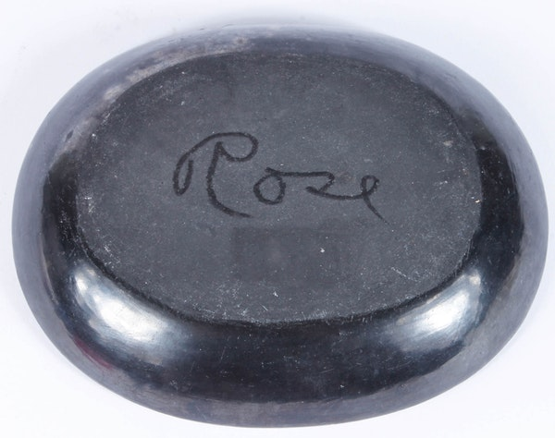
Overall recto |  |  |  |  | Overall verso

Condition Terms
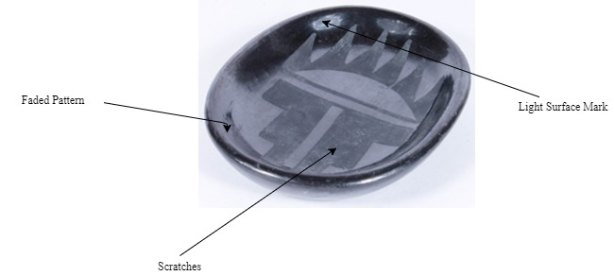

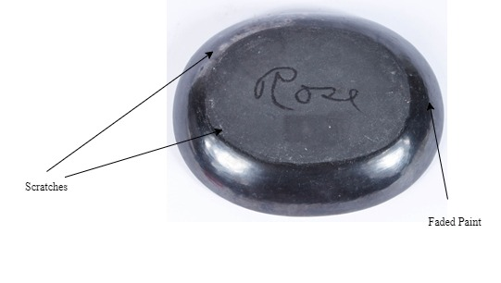

Deed of Gift
This Deed was made in accordance with the museum’s terms and conditions on (03/12/2017) between Montclair Art Museum and Marilyn and Stephen Greene.

Name(s): Marilyn Stephen Greene
Address: 375-clifton avenue City: Newark
State: New Jersey Zip Code: 07104
Phone: 718.641.5608 E-mail: maristep456@gmail.com
The document records gift by Marilyn Stephen Greene the following terms and conditions:
- Marilyn Stephen Greene is the owner of the dish pottery as described and that it is free from all claims.
- Marilyn Stephen Greene agrees that on the date specified, the Deed will be absolute, whether the museum is operational or not operational.
- The deed is issued in the willingness of an individual with whatever conditions given by the person.
- All our deeds are issued in accordance to certification that can be revisited in any case of a petition or whatsoever condition.
Date: 04-Dec-2017 Stamp: 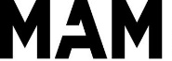
Sign:

Description of Gift

…………………………………………………………………………………………………….……………………………………………………………………………………………………………………………………………………………………………………………………
Object Name: Native American Rose Gonzales Signed Black dish Pottery.
………………………………………………………………………………………………….………………………………………………………………………………………………………………………………………………………………………………………………………
Artist: Rose Cata Gonzales
………………………………………………………………………………………………….………………………………………………………………………………………………………………………………………………………………………………………………………
Medium: Clay and matte black paint.
………………………………………………………………………………………………….………………………………………………………………………………………………………………………………………………………………………………………………………

Dimensions: 5.75" W x 1.0" H x 4.5" D.
………………………………………………………………………………………………….………………………………………………………………………………………………………………………………………………………………………………………………………
Condition: Good, Some light surface marks and scratches.…

I have read and agreed to the policy statement on this form. By my signature below. I accept the foregoing conditions and acknowledge reading any attached information.

Donor: Date: December 4, 2017
Witness: Date: December 4, 2017

The museum accepts your unconditional gift of the items(s) described above. The museum acknowledges in accordance with your expresses intention that it now has full title to, and responsibility for the gifted item(s).

Museum representative: Date: 04-Dec-2017

Receipt Form
Received by division of: Ware Pottery date: 06-Dec-2017

Museum representative: Osanna Urbay (Registrar) sign:

Forwarded to: Bruce Rainier (Preperator)

The objects listed are left in the temporary custody of the Montclair Art museum as a favor of the owner and on the initiative of the owner. Any opinion offered to the owner regarding the objects is for personal information and it may not be used in connection with any commercial transaction.
The museum personnel cannot make statements regarding the monetary value of an object nor are they or the museum liable for statements concerning the authenticity or identity of the object.
The museum will give the objects left in its custody the same care provided similar objects of its own, but it assumes no additional responsibilities or liabilities in regard to such objects. Insurance for objects left in custody will be carried by the owner. This receipt shall constitute a release and waiver of the Peabody museum, its employees, officers, and agents from any liability in connection with the objects while in temporary custody or in transit, except for clearly negligent conduct.
I agree to the above terms and conditions.

Signature of depositor: Date: December 6, 2017

Name of depositor: Wael Muhssen Dugdugi. Address: 25 manor drive, Newark, NJ 07106

Telephone: 001 352 278 1785

Owner: Marilyn Stephen Greene

Email: maristep456@gmail.com

Scheduled date of removal of object is: March 26, 2017
Objects have been deposited for the following purpose:

Identification: ………NA……. Examination for……NA……………….

Other: Exhibition purposes.

Description of objects deposited:

Does the owner have any objection to objects being altered for investigation?
- Yes √

- No

Please describe locality and conditions
- If found, please give exact location including city and street.
- If dug up, please describe color, texture and others and where they were found.
- If otherwise acquired, please give details. √
The dish pottery was acquired from the Native American Arts collection, from Marilyn Stephen Greene’s private following the appropriate procedure for the item acquisition.

Objects ready for pick-up, owner notified (date): December 20, 2017

It is hereby acknowledged that the objects listed above have been returned to the owner

Received by: …………………………………... Date: …………………...

Signature: ……………………………………...

9738 Central Ave
Montclair, CA 91763
909-624-0033

Fax: 909-624-3708

CERTIFICATE OF INSURANCE
This memorandum is for information only: it is not a contract of insurance but attests that a policy as numbered herein, and as it stands at the date of this certificate, has been issued by the Company. Said policy is subject to change by endorsement and to assignment and cancellation in accordance with its terms. The following is information from tire policy.
Policy Type | Museum Collection and Temporary Loans
Named Insured | Montclair Art Museum
Address | Montclair Art Museum,  3 South Montclair Ave.  Montclair, NJ 07042
Dates | December 26, 2017 to March 26, 2018.  12:06 AM Standard time at the place of issuance.
Limits of Liability | $ Object value
On the following Works of Art. | Object Name: Native American Rose Gonzales Signed Black dish Pottery.  Artist: Rose Cata Gonzales  Dates: 1900-1989
Company and Policy numbers. | ESI Insurance Agency Policy Number # 7709
Certificate Issued to | Lender: EBTH  Email: info@ebth.com

Authorized Representative: Date: December 4, 2017
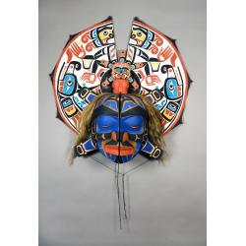
Object Three: Transformation Mask
Title: Transformation Mask, ca. 1984
Artist: Smith, Don (Lelooska) (1933 - 1996)
Descent: Cherokee, Kwakwaka'wakw
Medium: Cedar, pigment, muslin, hair.
Dimensions: 40 x 40 x 13 1/2 in. (101.6 x 101.6 x 34.3 cm)
Museum: The Montclair Art Museum
Credit line: Gift of Marilyn and Stephen Greene
Accession number: 2006.19.2

Catalogue Description:
This mask, the Mask of the Dawn, was created by Lelooska who was originally from the Cherokee descent but was adopted by the Kwakwaka'wakw community. He and his family are given the recognition for playing a great role in revitalizing the Kwakwaka'wakw culture. The above mask is very rare and special and such masks are usually for the purpose of re-enactments of family lineage stories and creation. Such masks have over the years been the most distributed form of art in the Northwest Coast.
The noble families were the ones who possessed the right to carve, commission and wear the curves. They treated them as supernatural treasures. These masks played a significant role during drama festivals that were held to recall and recognize heroic deeds from the mythic founders. During the event, the masks were accompanied with various songs, myths and dances.
Also, the mask reaffirms the cosmic and social order by combining the mythological history with the present days. They are still used in celebrations of the different seasons.
Shipping
The transformation Mask will not need any special shipping arrangements as the other art works, it will be sourced from Montclair Art Museum. The museum has a Native American collection in the vault located in the basement which has over 4,000 objects used to represent the cultural evolution and development of various communities in America. The transformation mask is one of them and all that will be needed is having the authorization by the museum collection manager to have the mask moved from the basement to the second floor in the Rotunda gallery.
Before moving the mask from the basement into the alcoves in Rotunda Gallery, an object request will be submitted via email to the collection manager. The email will entail the title and artist of the artwork, the reason for object request, the period of usage and the desired delivery method. After completing the elementary procedures and the request is accepted. The mask will be transported by the museum register. Being specialist in the field he/she will ensure that the mask is safely unmounted from the based and carried in great care to the second floor.
Packaging the Object
The transformation mask will be moved from the vault to rotunda gallery after covering the mask will be wrapped with a clean piece of cotton cloth and placed horizontally in a tray. The mask will be supported from underneath by laying it on a sheet of calico since the mask is very delicate and can be easily torn out or pulled of shape.
It will take two assistants to place the mask in the tray to avoid chances of folding. The tray will be cleaned prior the movement to ensure the mask is free from dust and any stains. The attached decorations will wrapped with accident free tissue to avoid corrosions.
Moving and Handling the object
The following process should be keenly observed in order to move the mask from the storage to the Rotunda gallery;
- Avoid wearing anything that might damage the object by scratching or snagging the surface.
- Determine my route to avert pathway disturbances by ensuring the path is safe and completely clear.
- Pay attention when removing the object from the shelf to avoid accidental damage.
- Nitrile gloves should be worn.
- Use both hands to lift the object.
- Note any obstacles (thresholders between galleries, steps, etc.)
- Move the object in its container if possible.
- Place the Native American mask on the right surface and ensure it is free from risk or damage.
- Make sure that it fits in the tray properly and no movements are made during moving.
It should not be pushed or moved on a rough surface to make sure that there are no scratches on it.
- The object should be transported on a cart via elevator through the galleries.
- When you handle the object use common sense to follow the basic to prevent damage to the mask
- The object must be polished before mounting it to the wall. This is to ensure that dust particles that may hide details are removed.
- When mounting the artefact, it is imperative to use both hands to protect the artefact from possible accidental drops.
- It is essential to examine if the object has any weakness lines that would result to breakage or destruction of the object.
- The person responsible for mounting must wear a pair of gloves to avoid leaving fingerprint impressions that may alter the details of the mask.
- The hooks used must be firm to ensure that the object does not fall and blunt to ensure that they do not damage the rear of the mask.
Display
The first thing will be to determine the art display layout. This will be in terms of size, shape, and type of the art object. The most appropriate position will be to hang the mask at the eye level based on the average height of an adult which is between 60 and 66 inches up from the floor to ensure maximum visibility. Special hooks will be used to hang the artefact, an aspect that will ensure that there is no damage of the alcove walls. The background will be a dull curtain so that the artefact stands out and the details become easily visible.
Another protective measure will be to avoid exposing the artefact to severe temperatures. To achieve this, the ideal temperature should be controlled well in the exhibition to maintain the object at ideal environment. Also, direct lighting from the sun will be avoided because the mask is made of delicate materials.

IncomingCondition Report
Accession # |  | Description |  |  |  |  | Date range
2006.19.2 |  | This mask, the Mask of the Dawn, was created by Lelooska who was originally from the Cherokee descent but was adopted by the Kwakwaka'wakw community. It is used for the purpose of re-enactments of family lineage stories and creation. |  |  |  |  | (1933 - 1996)
Collection |  | Credit line |  |  |  |  | Location
Native American Arts |  | Gift of Marilyn and Stephen Greene
Materials
Cedar, pigment, muslin and hair.

Dimensions in inches
Height |  | Width |  |  |  | Length
40 |  | 13 1/2 |  |  |  | 40
Condition (1-4, 1 being Poor and 4 being Very Good)
Overall | Soil |  | Stains |  |  | Losses |  | Fading
3 | 3 |  | 3 |  |  | 4 |  | 4
Check all that apply:
Evidence of Insect Infestation |  | Mold/ Mildew |  | Previous Repairs |  | Unstable Dyes |  | Label
X |  |  |  |  |  | X
Condition details
The Transformation Mask, ca. 1984 has some parts with fainted dye. Also, there is evidence of past insect activity, including accretion and holes.
Photographs
Overall recto |  |  |  |  | Zoomed View

Condition Terms
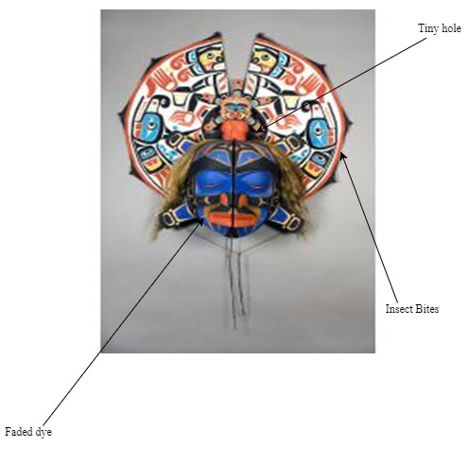

Object Movement Procedure

Object Name: Transformation Mask, ca. 1984 Artist: Smith, Don (Lelooska)
Accession number: 2006.19.2 Date of Installation: 26th Dec, 2017

Checklist:
- Two representatives from Montclair Art Museum have been informed about the movement of objects and will be present during the actual movement of the objects to Rotunda Gallery.
- All the equipment needed for installing such as mounting frames, nuts, screws, lighting is present prior to the movement
- The path from the museum storage to the intended Gallery is clear and free from other form of obstruction by objects or people.
- The art objects have been analyzed for any form of weakness or damage prior to the movement.
- A condition report for each of the selected artefacts is made available alongside a manual on the installation procedure.
- The intended museum space in Rotunda Gallery has been prepared and is ready for object installation.
  - All the previous artworks in the Gallery have been de-installed and returned to the museum storage.
  - Cleaning has been done in all the alcoves including furniture. This includes removing the exhibition labels on the wall.
  - Security and the museum staff have been informed of the upcoming installations and event.
  - There have been agreements to ensure the museum is attended on a daily basis and everything is in order before closure.
- A museum staff has been identified and selected to be present to oversee the installation and installation process.

Verified Museum Staff Signature:
Date: 06-December-2017

Object Four: Chief Blackbird
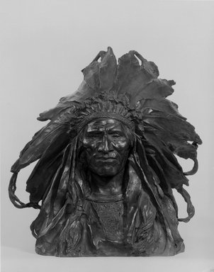
Object Name: Chief Blackbird, the Ogalla Sioux
Artist: Adolph Alexander Weinman, American, born Germany, 1870-1952
Medium: Bronze
Dates: modeled 1903, cast 1907
Dimensions: 16 3/8 x 12 1/2 x 11 1/2 in. (41.6 x 31.8 x 29.2 cm) 43.5 lb. (19.73kg)
Museum: Brooklyn Museum
Accession Number: 15.512
Credit Line: Gift of George D. Pratt

Catalogue Description
Bust portrait of Native American chief, facing frontally, wears elaborate feathered headdress and shirt with beaded or quilled bib; loose modeling. Condition: Good; powdery substance in crevices.
Shipping
This object will be treated as an item from out of state. It was sourced from the Brooklyn Museum, New York, United States. The object is sensitive to damage and must therefore be handled properly to reduce and minimize chances of damage. In this case of the headdress originating from out of state, the process involved is long and procedural and as such the following process should be considered.
- Identify a certified shipping company.
- Two men with a truck.
- Ensure that the headdress is insured from potential risks.
- Evaluate the size and weight limitations.
- Identify pickup and delivery times.
- Assess the costs and payment terms.
- Pay the respective local duties across the states.
It is essential and appropriate to write on the shipping box that the object in the box is delicate and should hence should handle with care. The security of the object is paramount. The location of the exhibition must secure to ensure the object remains safe from either robbery or stealing. Often, Newspaper and any other material must not be used as the fiber of the paper can scratch the surface of the pottery and make it lose its value.
Packing
Here are packaging specifications;
The ideal packaging crate dimensions will have a diameter of 50cm, a width of 40 cm and a height of 45 cm to ensure accuracy and suitability of the art object carriage. The crate dimensions exceed the art object as an allowance for the in-lining materials and the necessary locks on the crate. The transportation service will include the use of a custom-built crate that has an interior lining to act as a shock absorber for secure art object transportation. When crating for inter-state shipments the shipping company will have the responsibility of ensuring that the crating materials are appropriate. Additionally, the company will coordinate with the shipping representatives to strictly meet the pickup destinations and deadlines in order to receive the artwork in a timely fashion.
On the exterior, the packaging crate will be puncture proof, light-proof, water-tight, and protective against shock, vibration, and environmental changes. Additionally, evaluating the object's structure and planning for the worst possible travel scenario is critical in determining the object's orientation inside a packing container. An initial covering will be used to protect objects from abrasive packing materials and to serve as a moisture buffer.
Display
The following process should be keenly followed while creating a proper platform for the display of the artifact;
- Identify how long the exhibition will be.
- Understand the avenue of the display location and how people will access the platform.
- Identify the materials that will be used to construct the respective exhibitions.
- Ensure the location is safe and free from risks of breaking the artifact.
The art object will be installed temporarily in the alcove. The object should be placed on a suitable base or pedestal for greater visibility with a nique mount that cradles and supports the bottom. Based on the information and dimensions of the MAM Rotunda, the allocated space is well sized to fit the respective measurements of this artwork. Placing the headdress in the alcove will help the art object to be at an eye level making it easier for the audience to make observations effectively by allowing optimal viewing and exploration.
Considering the art object is three-dimensional, it will be displayed in a manner viewable from multiple angles. It will be very important to observe extreme care while unloading and maneuvering the art object from the crate and placing it in position with an aim to secure it. There is also a need to have additional safety concerns related to possible vandalism by potential ill-motivated audience, chances of accident drop or fall over during the exhibition. It is in this line that the Chief Blackbird art object will be secured by placing a little bit towards the middle of the alcove space.
Like any other works of art, lighting will play a vital role while displaying the art objects. In this instance, too much light will be avoided as it will wash out the details. Therefore, diffused light sources will be used to ensure the art object is well lit without washing or hiding any details.
Moving the Object
During this process, observe the following protocols;
- Wear gloves in order to move the object carefully avoiding careless dropping and leaving unnecessary marks on the object.
- Determine my route to avert pathway disturbances by ensuring the path is safe and completely clear.
- Pay attention when removing the object from the shelf to avoid accidental damage.
- Ensure storage space facilities effective viewing by the audience.
- Avoid wearing anything that might damage the object by scratching or snagging the surface.
- Use both hands to lift the object to the storage location.
- When you handle the object common sense to follow the basic to prevent damage to the battery
- Place the object on the right surface and ensure it is free from damage or risk that could cause breakage.


200 Eastern Parkway
Brooklyn, NY 11238-6052
Telephone: 718.638.5000
Fax: 718.501.6136
Incoming Condition Report
Reported by: Wael Dugdugi Date: December 6, 2017
Accession # |  | Description |  |  |  |  | Date range
15.512 |  | Chief Blackbird, the Ogalla Sioux  Bust portrait of Native American chief, facing frontally, wears elaborate feathered headdress and shirt with beaded or quilled bib; loose modeling. Condition: Good; powdery substance in crevices. |  |  |  |  | 1870-1952
Collection |  | Credit line |  |  |  |  | Location
American Arts |  | Gift of George D. Pratt |  |  |  |  | Not on view
Materials
Bronze
Dimensions in inches
Height |  | Width |  |  |  | Length
11 1/2 |  | 12 1/2 |  |  |  | 16 3/8
Condition (1-4, 1 being Poor and 4 being Very Good)
Overall | Soil |  | Stains |  |  | Losses |  | Fading
3 | 3 |  | 2 |  |  | 4 |  | 4
Check all that apply:
Evidence of Insect Infestation |  | Mold/ Mildew |  | Previous Repairs |  | Unstable Dyes |  | Label
 |  |  |  |  |  | X
Condition details
The art object is in Good condition with only some powdery substance in the crevices.
Photographs
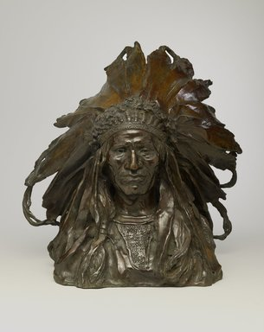 |  |  |  |  | 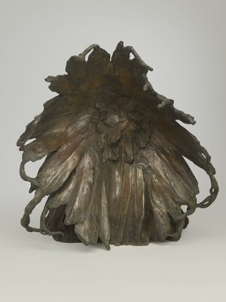
Overall recto |  |  |  |  | Overall verso

Condition Terms
Powdery substance

Receipt Form
Received by division of: Chief Blackbird, the Ogalla Sioux date: December 6, 2017

Museum representative: Osanna Urbay (Registrar) sign:

Forwarded to: Bruce Rainier (Preperator)

The objects listed are left in the temporary custody of the Montclair Art museum as a favor of the owner and on the initiative of the owner. Any opinion offered to the owner regarding the objects is for personal information and it may not be used in connection with any commercial transaction.
The museum personnel cannot make statements regarding the monetary value of an object nor are they or the museum liable for statements concerning the authenticity or identity of the object.
The museum will give the objects left in its custody the same care provided similar objects of its own, but it assumes no additional responsibilities or liabilities in regard to such objects. Insurance for objects left in custody will be carried by the owner. This receipt shall constitute a release and waiver of the Peabody museum, its employees, officers, and agents from any liability in connection with the objects while in temporary custody or in transit, except for clearly negligent conduct.
I agree to the above terms and conditions.

Signature of depositor: Date: December 4, 2017

Name of depositor: Wael Muhssen Duddugi. Address: 25 manor drive, Newark, NJ 07106

Telephone: 001 352 278 1785

Owner/agent: Brooklyn Museum

Address: 200 Eastern Parkway, Brooklyn, NY 11238-6052 Telephone: 718.638.5000

Scheduled date of removal of object is: March 26, 2017
Objects have been deposited for the following purpose:

Identification: ………NA……. Examination for……NA……………….

Other: Exhibition purposes.

Description of objects deposited:

Does the owner have any objection to objects being altered for investigation?
- Yes √

- No

Please describe locality and conditions
- If found, please give exact location including city and street.
- If dug up, please describe color, texture and others and where they were found.
- If otherwise acquired, please give details. √
The object was acquired from the Arts of the Americas collection in Brooklyn Museum following the appropriate procedure for the item acquisition.

Objects ready for pick-up, owner notified (date): 20-Nov-2017

It is hereby acknowledged that the objects listed above have been returned to the owner

Received by: …………………………………... Date: …………………...

Signature: ……………………………………..

INCOMING LOAN CONTRACT
AGREEMENT
The undersigned (“Lender”) hereby places the object(s) described herein in custody of the Montclair Art Museum for the purposes, and subject to the terms and conditions, set forth.

LENDER INFORMATION:
Name: Brooklyn Museum
Address: 200 Eastern Parkway
Brooklyn, NY 11238-6052

Telephone: 718.638.5000
Email: information@brooklynmuseum.org
OBJECT(S) DESCRIPTION(S):
Object Name: Chief Blackbird, the Ogalla Sioux
Artist: Adolph Alexander Weinman, American, born Germany, 1870-1952
Medium: Bronze
Dimensions: 16 3/8 x 12 1/2 x 11 1/2 in. (41.6 x 31.8 x 29.2 cm) 43.5 lb. (19.73kg)
PURPOSES/PERMISSIONS (check all that apply):
The Museum has the Lender’s permission to use the object(s) for:
- Exhibition √  Copying/Reproduction (commercial)
- Copying/Reproduction (non-commercial)
- Research

DESCRIPTION OF LOAN:
Dates: December 26, 2017 to March 26, 2018
Responsible for transportation: Lender Museum Shipping company√

CREDIT LINE:
Unless otherwise noted, the object(s) listed above will be credited in exhibition and publication with the statement “Courtesy of George D. Pratt”

SIGNATURE:
The Lender acknowledges that he/she has full authority and power to enter into this agreement, that he/she has read the conditions above and on the back of this form and that he/she agrees to be bound by them.
DATE
MUSEUM REPRESENTATIVE
Sign and date for return receipt:

LENDER DATE

LENDER Brooklyn Museum DATE: 03/12/2017

MUSEUM REPRESENTATIVE DATE: 03/12/2017
Osanna Urbay (Registrar)

9738 Central Ave
Montclair, CA 91763
909-624-0033

Fax: 909-624-3708

CERTIFICATE OF INSURANCE
This memorandum is for information only: it is not a contract of insurance but attests that a policy as numbered herein, and as it stands at the date of this certificate, has been issued by the Company. Said policy is subject to change by endorsement and to assignment and cancellation in accordance with its terms. The following is information from tire policy.
Policy Type | Museum Collection and Temporary Loans
Named Insured | Montclair Art Museum
Address | Montclair Art Museum,  3 South Montclair Ave.  Montclair, NJ 07042
Dates | December 26, 2017 to March 26, 2018.  12:06 AM Standard time at the place of issuance.
Limits of Liability | $ Object value
On the following Works of Art. | Object Name: Chief Blackbird, the Ogalla Sioux  Artist: Adolph Alexander Weinman  Dates: 1903-1907
Company and Policy numbers. | ESI Insurance Agency Policy Number # 6547
Certificate Issued to | Lender: Brooklyn  Address: 200 Eastern Parkway  Brooklyn, NY 11238-6052

Authorized Representative: Date: December 6, 2017

Object 5: Pair of Moccasins
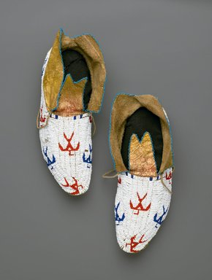
Object Name: Pair of Moccasins
Osage (Native American)
Artist: unknown
Date: early 20th century
Medium: Hide, beads
Dimensions each: 10 13/16 x 4 5/16 in. (27.5 x 11 cm)
Collections: Arts of the Americas
Museum: Brooklyn Museum
Accession number: 11.694.9035a-b

Catalogue Description:
Pair of moccasins with totally beaded blue and red thunderbird designs. According to Sean Standing Bear, (Osage) 10/20/2000, a non-Osage person might have made these because the birds are positioned upside down. Osage design dictates indicate the birds would point skywards.
Shipping
Shipping the pair of Moccasins from Brooklyn Museum will be in the same truck will involve a number of steps. The process will commence by making the object request from the museum where an email will be sent to the collection manager requesting for the quote and giving a rationale and the purpose of using this project. After the request is approve it would be perfect time to make the payment and embark on identifying a shipping company near the museum.
The next step would be to pay any duties required for transportation. Also, this art object would be insured which will cater for the potential risks. After evaluating the size and weight of the artefact the payment to the shipping company and the receipt backed up in the phone memory space or in a compute which will be after agreeing on the payment terms. The last step in the shipping process will involve identifying the pickup destination and the specific delivery time.
Packaging
Packaging the pair of Moccasins should be done appropriately to ensure there is no part of the artwork that gets damaged during the shipping process. There are few risks on these art object compared to the other mentioned where most of them are fragile and require extreme care. The reason being that the pair is made of moccasins and beads which can be transported even without a mandatory need of a box.
However, to avoid taking chances a box will be needed for packaging. An average box with a length of 30 inches, with of 20 inches and a height of 10 inches will be enough. The pair will be stuffed with cotton in the inside or improvised pieces of cloth to ensure they don’t get wrinkled and they remain in their original form and do not get crushed during transportation. The preferable box would be plastic one with a label on top showing the size, the material and the type of shoes being transported. This information will serve the purpose of ensuring the shipping representatives have enough information to determine how they will handle the art object.
The label should be covered using enough and clear tape to hold in position as well as protect it from getting damaged in case the box is exposed to rain or any other liquids. Another strategy would be to write down the labels using a dark pen or a magic marker to ensure that the label won’t rub off in between the shipping process from Brooklyn Museum to the Rotunda Gallery in Montclair Art Museum.
The packaging box should include an insect’s repellent. This will protect the pair of Moccasins from getting damaged by spiders, ants or any other creepy crawlies that may find their way into the box during the shipping process or the storage period. The repellents can be gotten from any stores.
Display
- While displaying the pair of moccasins in the Alcoves, the stuffed pieces of cloth will be removes so as to show the shoes details on the inside.
- The pair will be held with hands donned in gloves during the installation period where shoes will be placed one after the other.
- The shoes will be displayed in a pedestal glass case high enough to ensure that the audience get optimal visibility of the pair of moccasins. This is important as the object contain small details that may not be visible from a floor level such as the beaded blue and red thunderbird designs.
- The display case has been selected as an excellent way to showcase the artefact and spark consumer interest while still keeping the pair of moccasins safe and secure which will prevent the art object from touch, accidental drops or even any form of vandalism.
- Diffused lighting will also be necessary to illuminate the pair in the display case. Appropriate illumination will influence the visitor’s mood and emphasize the details of art objects such as the beaded bird patterns as well as optimize the visitor's visual experience.
- The pair of moccasins will be displayed vertically in the case a position that will be ideal for the object exploration.
- Also like any other object it will be necessary to include the object label which will provide the audience with the information concerning the artefact.

De-installation of the Art Objects

One object specifically the Water Jar will be returned to the Newark Museum, in the New Jersey- local transit, by using local art shipping company, two men with a truck. The same packaging procedure will be implemented during de-installation and more layers of wrappers added as required.

The Ware Pottery will remain in the museum for acquisition. However, together with the Transformation Mask, the objects will be moved to the museum storage.

The Chief Blackbird art object and the Pair of Moccasins will be aired back to the source museums using their same crates used for the initial shipping and the same procedure Brooklyn Museum, in the New York, by using the art shipping company. However, in the event that the initial shipment turns out to be unsatisfactory, a different service provider will be chosen.

200 Eastern Parkway
Brooklyn, NY 11238-6052
Telephone: 718.638.5000
Incoming Condition Report
Name: Wael Dugdugi Date: December 5, 2017
Accession # |  | Description |  |  |  |  | Date range
11.694.9035a-b |  | Pair of moccasins with totally beaded blue and red thunderbird designs. According to Sean Standing Bear, (Osage) 10/20/2000, a non-Osage person might have made these because the birds are positioned upside down. Osage design dictates indicate the birds would point skywards. |  |  |  |  | Early 20th century
Collection |  | Credit line |  |  |  |  | Location
Arts of the Americas |  | Museum Expedition 1911, Museum Collection Fund |  |  |  |  | Not on view
Materials
Hide and beads
Dimensions in inches
Height |  | Width |  |  |  | Length
NA |  | 4 5/16 |  |  |  | 10 13/16
Condition (1-4, 1 being Poor and 4 being Very Good)
Overall | Soil |  | Stains |  |  | Losses |  | Fading
3 | 3 |  | 2 |  |  | 4 |  | 3
Check all that apply:
Evidence of Insect Infestation |  | Mold/ Mildew |  | Previous Repairs |  | Unstable Dyes |  | Label
X |  |  |  |  |  | X
Condition details
The Pair of moccasins is in good condition but has some cream stain, loss of the beading pattern and loss of hide stitching. Also it has a bent sole as well as a worn out lace on the right leg shoe.
Photographs
 |  |  |  |  | 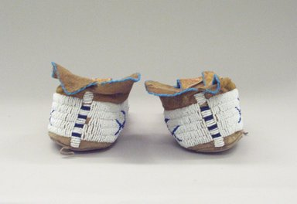
Overall recto |  |  |  |  | Overall verso

Conditioning Terms
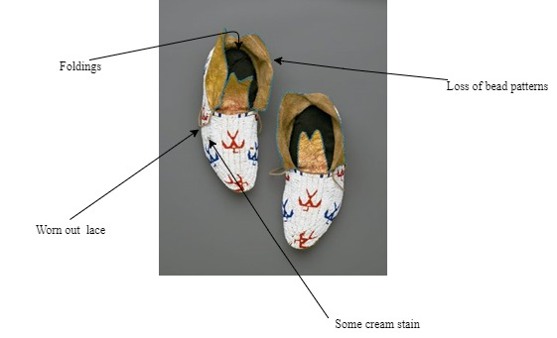

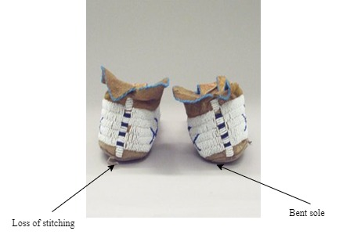

Receipt Form
Received by division of: Pair of Moccasins Date: December 4, 2017

Museum representative: Osanna Urbay (Registrar) sign:

Forwarded to: Bruce Rainier (Preperator)

The objects listed are left in the temporary custody of the Montclair Art museum as a favor of the owner and on the initiative of the owner. Any opinion offered to the owner regarding the objects is for personal information and it may not be used in connection with any commercial transaction.
The museum personnel cannot make statements regarding the monetary value of an object nor are they or the museum liable for statements concerning the authenticity or identity of the object.
The museum will give the objects left in its custody the same care provided similar objects of its own, but it assumes no additional responsibilities or liabilities in regard to such objects. Insurance for objects left in custody will be carried by the owner. This receipt shall constitute a release and waiver of the Peabody museum, its employees, officers, and agents from any liability in connection with the objects while in temporary custody or in transit, except for clearly negligent conduct.
I agree to the above terms and conditions.

Signature of depositor: Date: December 4, 2017

Name of depositor: Wael Muhssen Duddugi. Address: 25 manor drive, Newark, NJ 07106

Telephone: 001 352 278 1785

Owner/agent: Brooklyn Museum

Address: 200 Eastern Parkway, Brooklyn, NY 11238-6052 Telephone: 718.638.5000

Scheduled date of removal of object is: March 26, 2017
Objects have been deposited for the following purpose:

Identification: ………NA……. Examination for……NA……………….

Other: Exhibition purposes.

Description of objects deposited:

Does the owner have any objection to objects being altered for investigation?
- Yes √

- No

Please describe locality and conditions
- If found, please give exact location including city and street.
- If dug up, please describe color, texture and others and where they were found.
- If otherwise acquired please give details. √
The object was acquired from the Arts of the Americas collection in Brooklyn Museum following the appropriate procedure for the item acquisition.

Objects ready for pick-up, owner notified (date): December 26, 2017

It is hereby acknowledged that the objects listed above have been returned to the owner

Received by: …………………………………... Date: …………………...

Signature: ……………………………………..

INCOMING LOAN CONTRACT
AGREEMENT
The undersigned (“Lender”) hereby places the object(s) described herein in custody of the Montclair Art Museum for the purposes, and subject to the terms and conditions, set forth.

LENDER INFORMATION:
Name: Brooklyn Museum
Address: 200 Eastern Parkway
Brooklyn, NY 11238-6052

Telephone: 718.638.5000
Email: information@brooklynmuseum.org
OBJECT(S) DESCRIPTION(S):
Object Name: Pair of Moccasins
Osage (Native American)
Artist: unknown
Date: early 20th century
Medium: Hide, beads
Dimensions each: 10 13/16 x 4 5/16 in. (27.5 x 11 cm)

PURPOSES/PERMISSIONS (check all that apply):
The Museum has the Lender’s permission to use the object(s) for:
- Exhibition √  Copying/Reproduction (commercial)
- Copying/Reproduction (non-commercial)
- Research

DESCRIPTION OF LOAN:
Dates: December 26, 2017 to March 26, 2018
Responsible for transportation: Lender Museum Shipping company√
CREDIT LINE:
SIGNATURE:
The Lender acknowledges that he/she has full authority and power to enter into this agreement, that he/she has read the conditions above and on the back of this form and that he/she agrees to be bound by them.
DATE
MUSEUM REPRESENTATIVE
Sign and date for return receipt:

LENDER DATE

LENDER Brooklyn Museum DATE: 03/12/2017

MUSEUM REPRESENTATIVE DATE: 03/12/2017
Osanna Urbay (Registrar)

9738 Central Ave
Montclair, CA 91763
909-624-0033

Fax: 909-624-3708

CERTIFICATE OF INSURANCE
This memorandum is for information only: it is not a contract of insurance but attests that a policy as numbered herein, and as it stands at the date of this certificate, has been issued by the Company. Said policy is subject to change by endorsement and to assignment and cancellation in accordance with its terms. The following is information from tire policy.
Policy Type | Museum Collection and Temporary Loans
Named Insured | Montclair Art Museum
Address | Montclair Art Museum,  3 South Montclair Ave.  Montclair, NJ 07042
Dates | December 26, 2017 to March 26, 2018.  12:06 AM Standard time at the place of issuance.
Limits of Liability | $ Object value
On the following Works of Art. | Object Name: Pair of Moccasins  Artist: unknown
Company and Policy numbers. | ESI Insurance Agency Policy Number # 7547
Certificate Issued to | Lender: Brooklyn  Address: 200 Eastern Parkway  Brooklyn, NY 11238-6052

Authorized Representative: Date: December 4, 201

Illustrated Checklist

object 1: Pair of Moccasins
Osage (Native American)
Artist: unknown
Date: early 20th century
MEDIUM: Hide, beads
DIMENSIONS Each: 10 13/16 x 4 5/16 in. (27.5 x 11 cm)
Location: Brooklyn Museum
ACCESSION NUMBER: 11.694.9035a-b
CATALOGUE DESCRIPTION: Pair of moccasins with totally beaded blue and red thunderbird designs. According to Sean Standing Bear, (Osage) 10/20/2000, a non-Osage person might have made these because the birds are positioned upside down. Osage design dictates indicate the birds would point skywards.
Object 2: Chief Blackbird, the Ogalla Sioux
Adolph Alexander Weinman
ARTIST: Adolph Alexander Weinman, American, born Germany, 1870-1952
MEDIUM: Bronze
DATES: modeled 1903, cast 1907
DIMENSIONS:16 3/8 x 12 1/2 x 11 1/2 in. (41.6 x 31.8 x 29.2 cm) 43.5 lb. (19.73kg)
Museum: Brooklyn Museum
ACCESSION NUMBER: 15.512
CREDIT LINE: Gift of George D. Pratt
CATALOGUE DESCRIPTION: Bust portrait of Native American chief, facing frontally, wears elaborate feathered headdress and shirt with beaded or quilled bib; loose modeling. Condition: Good; powdery substance in crevices.

Object 3: Native American Rose Gonzales Signed Black Ware Pottery.
Artist: Rose Cata Gonzales (1900 – 1989)
Dimensions: 5.75" W x 1.0" H x 4.5" D
MEDIUM: Ceramic
Location: Newark, Private Collection
Condition: Good, Some light surface marks, scratches.
Catalogue Description: This round pottery dish was done by Rose Potter Rose Cata Gonzales (1900 – 1989). She is a Native American who incised black on ceramic dish. She was credited as an innovator of the deeply carved pottery technique which was greatly used by San Ildefonso potters around 1930s. The dish is almost metallic sheen and is decorated with a matte black geometric design of six triangles on an arch, with step patterns below. The underside is signed “Rose”. Rose is believed to have learned pottery making from her mother-in-law, Ramona Sanchez Gonzales.

Object 4: Water Jar
Artist: unknown
MEDIUM: Clay, pigment
DATES: 1825-1850
DIMENSIONS:12 3/4 x 12 3/4 in. (31.5 x 33.5 cm)
ACCESSION NUMBER 03.325.4723
Location: The Newark Museum
CATALOGUE DESCRIPTION: Jar, black on white exterior. This oversize water jar has a butterfly design, a symbol often associated with water, set within a large, continuous stepped figure on the body. The neck design consists of a continuous stepped band with curled figures attached. In use it would have a piece of hide stretched and tied across the top, thus accounting for the rough edges on the jar. Red writing on base reads "03.325.4723" and "03.132," partial number is written in black on the side.

object 5: Smith, Don (Lelooska) (1933 - 1996)
Transformation Mask, ca. 1984
Cherokee, Kwakwaka'wakw
Cedar, pigment, muslin, hair
DIMENSIONS: 40 x 40 x 13 1/2 in. (101.6 x 101.6 x 34.3 cm)
Museum: The Montclair Art Museum
Gift of Marilyn and Stephen Greene
ACCESSION NUMBER: 2006.19.2
Catalogue Description:This mask, the Mask of the Dawn, was created by Lelooska who was originally from the Cherokee descent but was adopted by the Kwakwaka'wakw community. He and his family are given the recognition for playing a great role in revitalizing the Kwakwaka'wakw culture. The above mask is very rare and special and such masks are usually for the purpose of re-enactments of family lineage stories and creation. Such masks have over the years been the most distributed form of art in the Northwest Coast.

